A Project Report

On

SHOPPING CENTRE MANAGEMENT
SYSTEM

by

Abhishek Mundada (Seat No.T9168)
Shivam Ambadkar (Seat No.T9173)

Under the guidance of
Prof V. D. Ghonge



Department of Information Technology
Smt. Kashibai Navale College of Engineering, Pune-41
Accredited by NBA
SAVITRIBAI FULE UNIVERSITY OF PUNE
2019-2020
Sinhgad Technical Education Society,
Department of Information Technology
Smt. Kashibai Navale College of Eng ineering , Pune-41

Date:

CERTIFICATE

This is to certify that,
Abhishek Mundada (Seat No.T9168)
Shivam Ambadkar (Seat No.T9173)

of class T.E IT; have successfully completed their project work on “Shopping Centre Management System” at Smt. Kashibai Navale College of Engineering, Pune in the partial fulfilment of the Graduate Degree course in T.E at the department of Information Technology, in the academic Year 2019-2020 Semester – I as prescribed by the University of Pune.

Prof. V. D. Ghonge Prof. R. H. Borhade
Guide Head of the Department
(Department of Information Technology)

Acknowledgements

We are very thankful to all the teachers who have provided us valuable guidance towards the completion of this project on Shopping Centre Management System as part of the syllabus of bachelor’s course. We express our sincere gratitude towards cooperative department who has provided us with valuable assistance and requirements for the system development.
We are very grateful and want to express our thanks to Prof. V. D. Ghonge for guiding us in right manner, correcting our doubts by giving us their time whenever we required, and providing their knowledge and experience in making this project. We are also thankful to the HOD of our Information Technology department Prof. R.H.Borhade for his moral support and motivation which has encouraged us in making this project. The acknowledgement will be incomplete if we do not thank our Principal Prof. Dr. A. V. Deshpande, who gave us his constant support and motivation which has been highly instrumental in making our project.

Abhishek Mundada (Exam Seat No. )
Shivam Ambadkar (Exam Seat No. )

i
Contents

Sr. No. | Topic |  | Page No.
 | Acknowledgement |  | i
 | Contents |  | ii
 | List of Tables |  | iii
 | List of Forms |  | iv
 | Acronyms |  | vi
 | Abstract |  | vii
Chapter-1 | Introduction |  | 1
 | 1.1 | Motivation | 1
 | 1.2 | Problem Statement | 1
 | 1.3 | Framework of the proposed work in project | 2
Chapter-2 | Literature Review |  | 3
 | 2.1 | Introduction | 3
 | 2.2 | Existing methodologies | 3
 | 2.3 | Proposed methodologies | 4
Chapter-3 | Software Requirement Specification |  | 5
 | 3.1 | Hardware Requirements | 5
 | 3.2 | Software Requirements | 5
Chapter-4 | Assumptions |  | 6
Chapter-5 | Entity-Relationship Diagram |  | 8
Chapter-6 | Tables |  | 9
Chapter-7 | Forms |  | 12
Chapter-8 | Features |  | 26
Chapter-9 | Conclusion |  | 28
 | References |  | 29

List of Tables

Table No. | Title | Page No.
 | Customer Details Table | 9
 | Employee Details Table | 10
 | Items Details Table | 10
 | OrderItem Details Table | 10

List of Forms

Form No. | Title | Page No.
7.1 | Login Screen | 12
7.2 | Menu Screen | 13
7.3 | Customer Details | 13
7.4 | Item Details | 14
7.5 | Employee Details | 14
7.7 | Order Item Details | 15
7.8 | Description of project. | 15
7.9 | Product Purchased Customer Details | 15
7.10 | History Of Customers | 15

Acronyms

VB | Visual Basic
RS | Record Set
CONN | Connection
MDSN | Microsoft Developers Network
ADODC | ActiveX Data Object Database Connection
ADODB | ActiveX Data Object for DataBase

Abstract

The basic purpose of the project “Shopping Centre Management System” is to develop software that keeps record of the customer purchasing items and to give satisfactory services to them. With this project we can maintain various records and perform operations on them. We can keep record of the items and products and their history. This project will help to ease the workload of the employees working in the Shop and will also execute jobs which used to be done on paper in an errorless manner. With the help of this project, we can thus evaluate the total item sold by the Shop. It thus decreases the tiresomeness of the job to a great extent. This software increases the efficiency of the operations performed in Shopping Centre.

Chapter 1
Introduction

  - Motivation
This Shopping Centre is for all customers. Our system is extremely useful to both the administrator and the customer as it is very simple and efficient to use and moreover the administrator can always keep the track of any kind of help needed by customer at any stage. The main purpose behind the design of our system is to computerise the entire working of the Shopping Centre in a consolidated database system for ease of operations and maintenance.
One more important purpose of our system is that it can give faster services to the customer and decreases the tiresome job of doing the paper work to a great extent.

  - Problem statement
To develop a software for managing the operations of a Shopping Centre Database Management.
This system includes the following:
- Collection of customer information which includes his personal details (if any).
- Information of different types of items (ex. Bat, Tshirt, Chocolates).
- Collection of different types of Rates for different items and keeping a log of the items sold or purchased by user.
- Maintenance and updation of the rates, items and customer database from time to time.
- Maintain record of the supplier.

1.3 Framework of proposed work in project
The main purpose behind the design of our system is to computerise the entire working of the Shopping Centre in a consolidated database system for ease of operations and maintenance. By this an administrator can maintain the record of the customer, their detail and also the record of the items which are available in the shopping centre. Administrator can make a log of items their rates as well as keep the track if they need to contact supplier for product.
1

Administrators can login to the system from any terminal by entering their username and password. The administrator console provides a central view of statistics generates various types of reports and allows the administrator to change settings related to the shop. The GUI would be developed in Visual Basic 8.2.The database will be maintained in Oracle 8i. The communication between front end and database will be through ADODC, ADODB and data environment.

Chapter 2
Literature review
2.1 Introduction

The current method for entering into the Shopping Centre is a very much time consuming process. The Administrator has to fill in different information from time to time for each customer. The administrator has to perform various complex tasks for maintaining the whole database. He has to go through all records to maintain and arrange them properly.
The system being designed is administrator-oriented. It simplifies the identification information collection from the customer and automates the process wherever possible.
If the current method of maintaining the records in Appliance shop is used, then there is a possibility of misuse. To solve this problem, there should be such a system which can make the whole process easier for administrator.

2.2 Existing methodologies
Following are the existing methodologies:
- Collection of customer information randomly.
- The administrator has to fill different information every time for each customer.
- The administrator has to perform various complex tasks manually for maintaining the whole database.
- Data of various items are monitored properly .

2.3 Proposed methodologies
Following are the proposed methodologies:
- Collection of customer information which includes his personal details to maintain the record in a full authorized way.
- The administrator has to fill the information only at main counter and then the generated customer ID will be forwarded at every stage so that the tedious job of filling the information before buying any item gets reduced.
- Administrator has been provided a username and password to facilitate the tracking of their activities.
- The complex job of administrator will be reduced by automatic generation of various reports and calculation of buy-sale Records.
- Any modifications made by the administrator are consistently implemented throughout the shopping centre.

Chapter 3
Software requirement specifications
3.1 Software requirements
Following are the software requirements
- Microsoft® Visual Basic 8.2
- Oracle Database 8.0
- Microsoft® Windows® XP

3.2 Hardware requirements
Following are the hardware requirements
- Intel Pentium-based processor (Minimum 1.7GHz Pentium 4 Processor)
- Minimum 40GB HDD
- Minimum 256MB RAM
- Monitor
- Keyboard
- Mouse

Chapter 4
Assumptions
4.1 General Assumptions
Following are the general assumptions in the developed software:
- All the entries those are to be entered are less than the length which is already defined for each attribute.
- The Appliance shop contains the following objects:
  - Customer
  - Items
  - Admin
  - OrderItem

- The following type of user is only allowed to use the database:
  - Administrator

4.2 Assumptions for Customer
The assumptions from the point of view of a Customer are as follows:
- Every customer is automatically allotted a Customer ID which is the primary key for the corresponding table. This Customer ID cannot be changed at any point by user of the software.
- Customer can be of two types: new vcustomer who is visiting the shop for the first time and existing customer who has early already bought a product.
- Visitors have to pay for every product he/she had bought .
.

4.3 Assumptions for Admin
The assumptions from the point of view of a staff member are as follows:
- Every staff member is appointed by the Administrator of the shop.
- Administrator has a unique username and password which is used to login to the software database.
.

  - Financial Assumptions
The assumptions for generating financial reports are as follows:
- A Financial year begins on 1st of April and ends on 31st of March, Any revenue and expenses occurring between this period are considered for the corresponding annual report.
- The discount is allocated to the customers if necessary.
- The administrator can change the value of discount given to the customers when they purchase the items.

Chapter 5
E-R Diagram

E-R model i.e. Entity Relation model is based on a perception of real world that consists of set of basic objects called entities and relationship among these objects. In the E-R diagram shown below, there are 10 entity sets. The entity sets are related to each other and are shown related to each other by a diamond. Each entity contains some attributes which are related to it. A primary key is nothing but a key chosen by a designer as the principal means of identifying entities within an entity set. A primary key is represented in an ellipse by a line under it. Cardinality of relationships is mentioned as one-to-one or one-to-many.

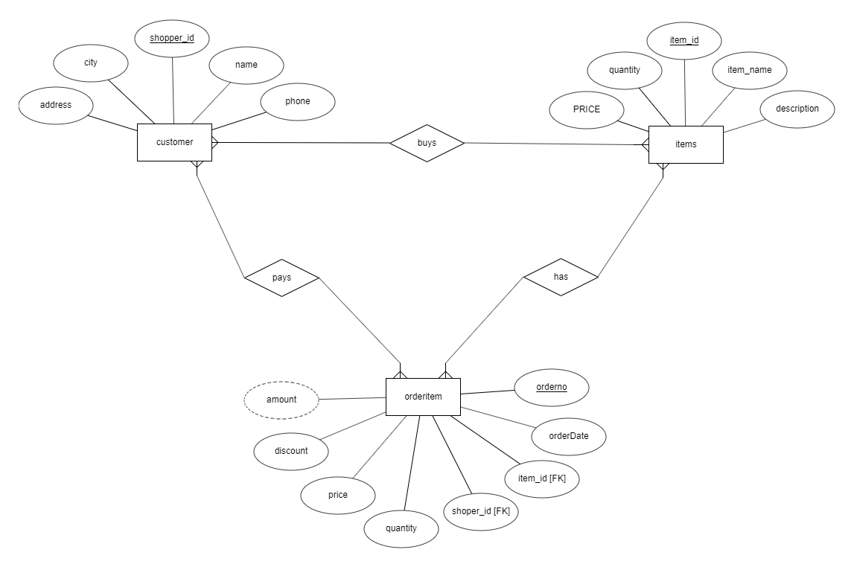
Chapter 6
Tables

Table 6.1. Attributes of Tables.
ENTITY | ATTRIBUTES | PRIMARY KEY | FOREIGN KEY
Customer | shopper_id, name, address,  city , phone_no | shopper_id
Items | item_id, item_name, description,  PRICE,quantity | item_id
Orderitem | orderno, orderDate, item_id,  shopper_id,quantity, price, discount,  amount | orderno | shopper_id,  item_id

Table 6.2.Customer.
shopper_id | name | city | phone | address
130 | Raj | Latur | 9933448800 | Aadarsh Colony
131 | Rahul | Pune | 9422094220 | Mukund Nagar

This table gives the detailed information about customer who purchased from shop.

6.4. Administrator.

Username | Password
admin | admin

This is the most important which contains the username and password of the administrators authorized to manage the shop.

Table 6.5. items

item_id | item_name | description | PRICE | quantity
103 | BAT | REEBOK | 650.00 | 98
104 | Perk | Nestle | 10.00 | 80
105 | Tshirt | Levis | 1000.00 | 95

This table gives the information about different items available in shop and make them available to customer.

Table 6.6. orderitem

orderno | orderDate | item_id | shopper_id | quantity | price | discount | amount
7 | 2019-10-15 | 103 | 130 | 2 | 650.00 | 10.00 | 1170.00
8 | 2019-10-15 | 105 | 131 | 5 | 1000.00 | 10.00 | 4500.00
9 | 2019-10-15 | 104 | 130 | 20 | 10.00 | 0.00 | 200.00

This table gives the information about customers ordering items and also at which date.

Chapter 8
Features
The main purpose behind the design of our system is to computerise the entire working of the Shopping Centre in a consolidated database system for ease of operations and maintenance. The users can login to the system by using any terminal and interact with the software. The prominent features of the software can be described as follows;

8.1 Customer Data
Administrator can enter the data of customer to maintain the record of customers. Customer’s id,
Customer’s name, Address, City, Phone_no are mentioned to register in the record. The customer details can be then updated and deleted as necessary.

8.3 Items
The database maintains the record of the items that are available in the shopping centre for the customers by the staff member. The items and it’s details are mentioned that are available in the shopping centre to keep the track of the products also to save it in record .

8.4 OrderItem
The Administrator has to keep the record of items that they have purchased by the customers. To keep the record of the items purchased by particular customers. Here, also quantity of items and discount for the items are also maintained. Hence, Customer and items records are maintained.

Chapter 9
Conclusion
In today’s world computers are used to increase the speed of the process. Hence this project aims on efficient and simple management of the shopkeeper or admin and the customers database and to update them. Thus this project provides faster and better approach to do so. Being cheap this is also easy to implement.

References

- Steven Holzner, “Visual Basic 6 Black Book”, ISBN: 1576102831
- Silberschatz A., Korth H., Sudarshan S., "Database System Concepts", 4th Edition, McGraw Hill Publishers
- Microsoft Developers Network (MSDN) Library
- Website: http://www.vb-code.net/
- Website: http://www.bigresource.com/
- Website: http://www.expertsexchange.net/
- Website: http://www.vbtutor.net/

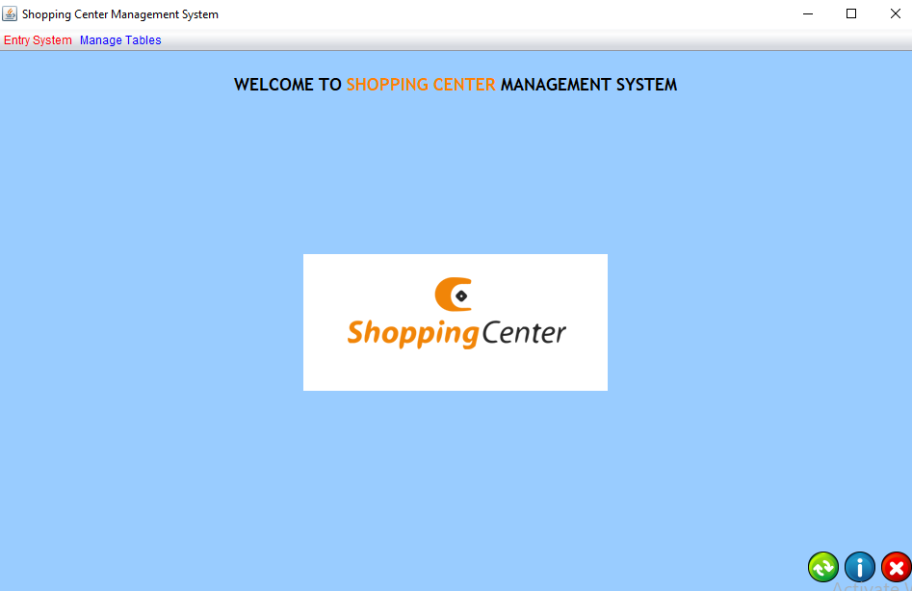

Form 7.2 Main Menu
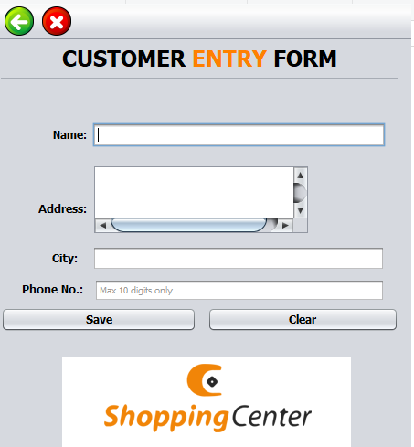

Form 7.3 Customer Entry
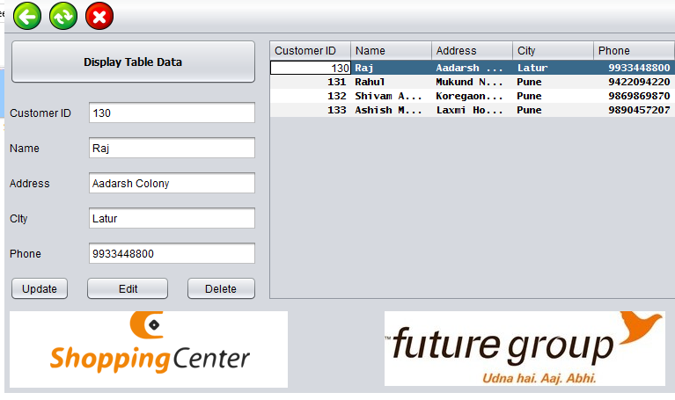
Form 7.4 Customer Entry Display Table
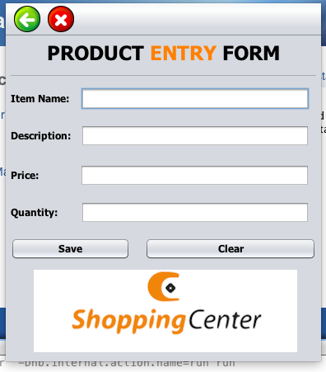

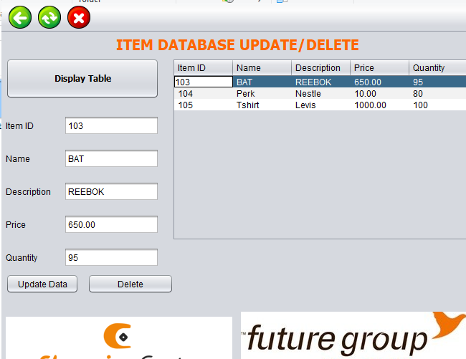
Form 7.5 Item Table Display Form
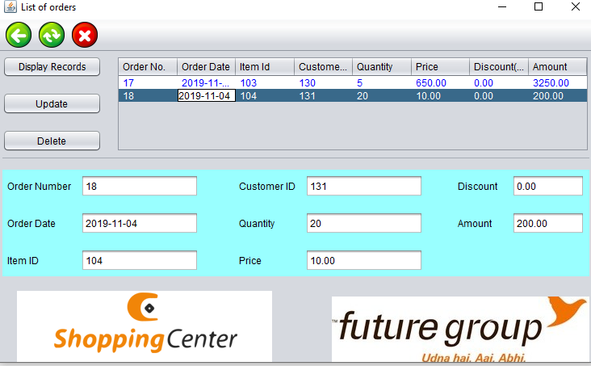

Form 7.6 OrderItem Table Display Form
